Flutter environment audit and first widget exercise A
Verbose output screenshot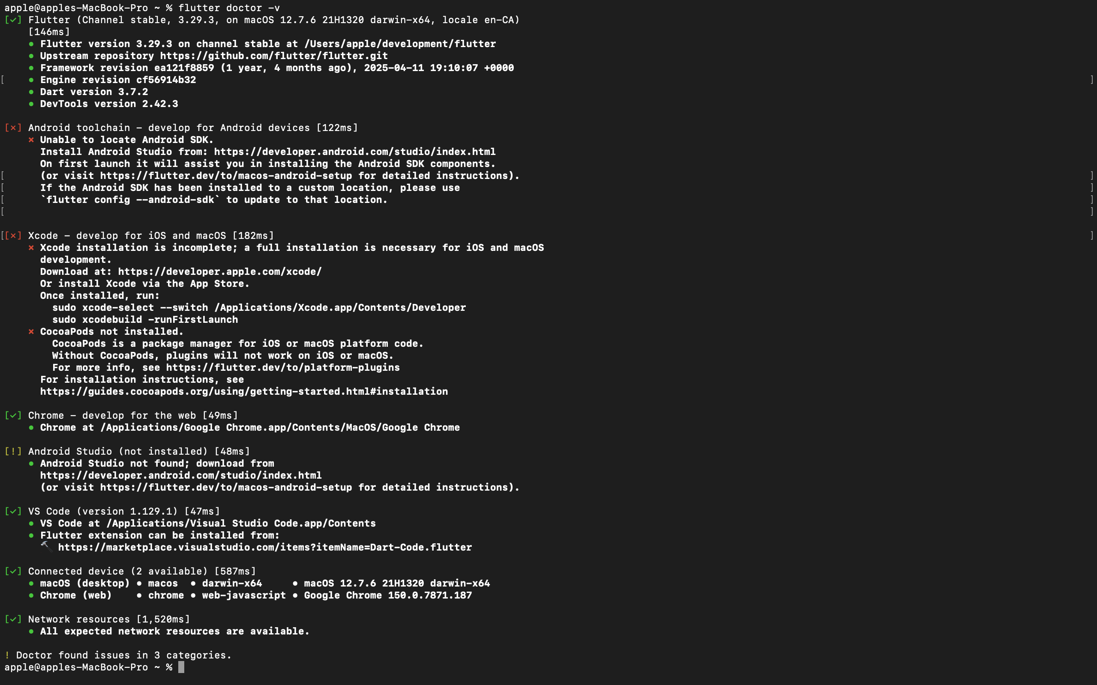

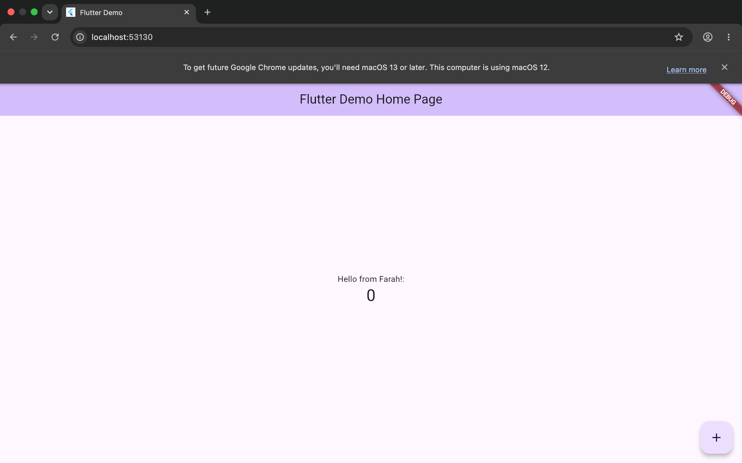

Exercise A — Worksheet Explanation.
The lib/main.dart file contains the main Dart code for the Flutter application, including the code that starts the app, creates the user interface, and controls its behavior. The MyApp class is the root widget that sets up the application, including its theme and the first screen. The MyHomePage class is a Stateful Widget that manages the main screen and its changing counter value. The Floating Action Button calls the _incrementCounter() function when it is pressed. This function increases the counter and uses setState() to tell Flutter that the state has changed, causing the user interface to rebuild and display the updated value.

EXERCISE B
CREATE TABLE.
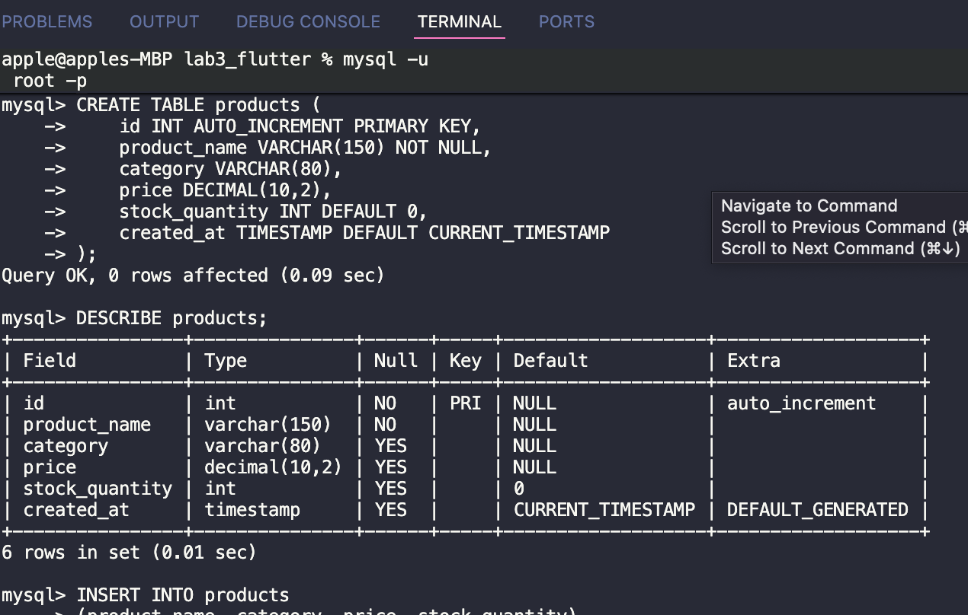

RETRIEVE ALL products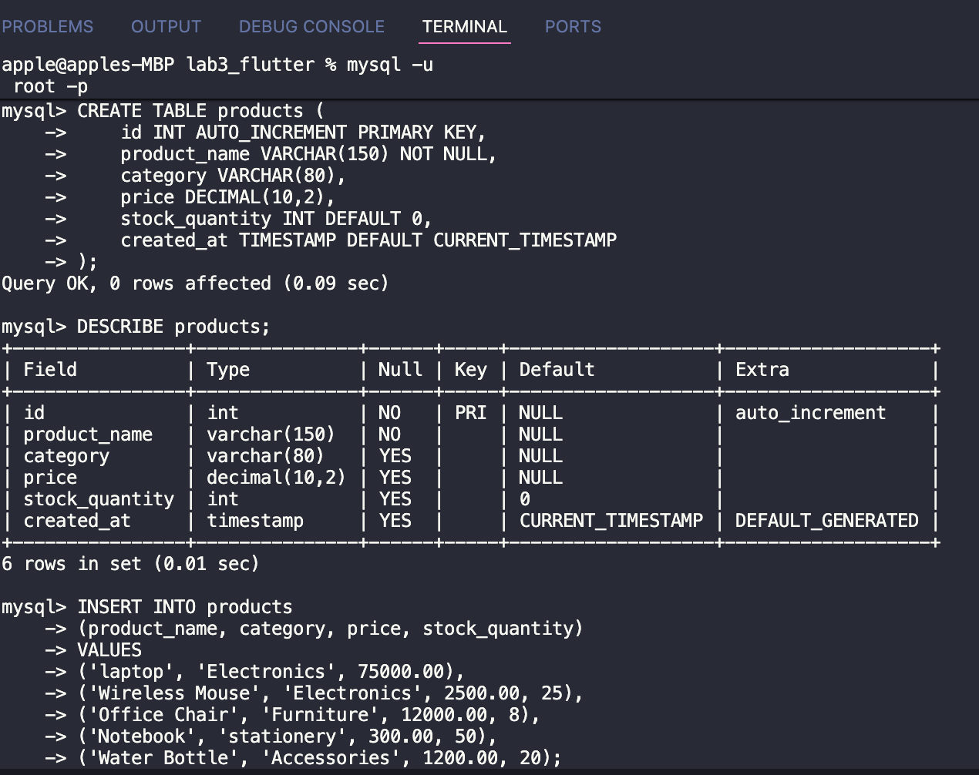

SELECT WHERE category.
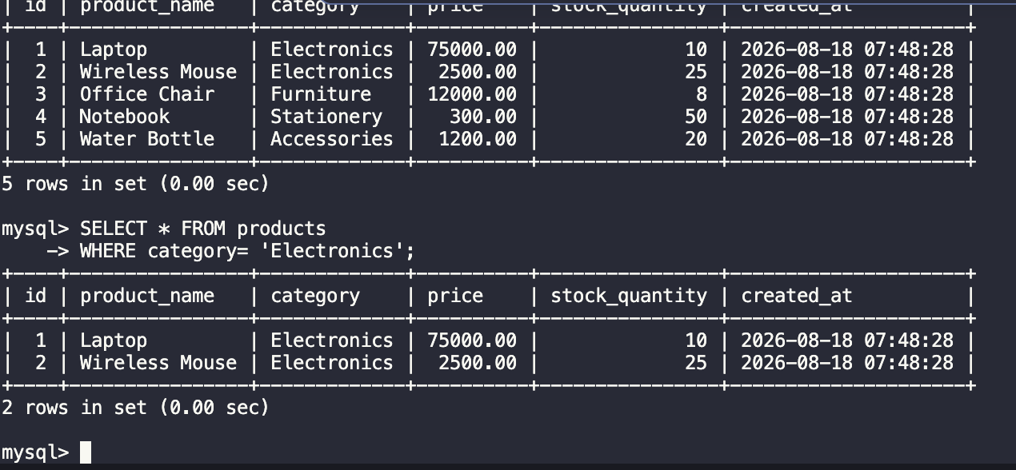

SELECT ORDER BY PRICE.
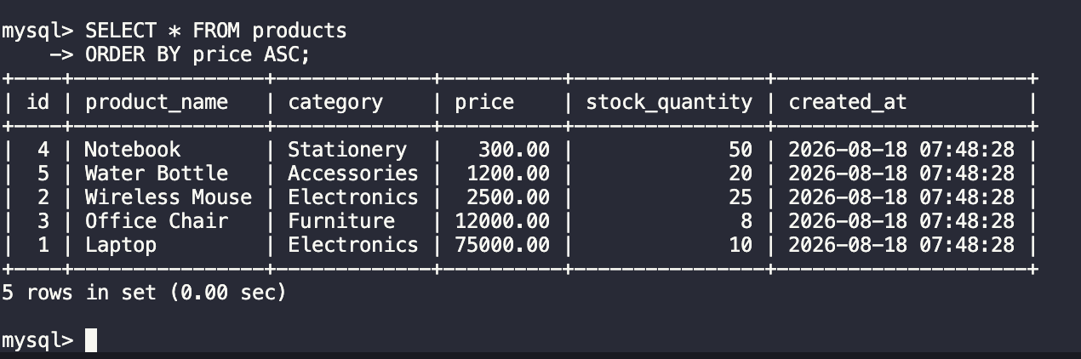

MySQL Database Design and Querying

Worksheet Answer
DECIMAL(10,2) is a numeric data type that stores up to 10 digits in total, with 2 digits after the decimal point. It is preferred over FLOAT for currency because it provides precise values and avoids the rounding problems that can occur with floating-point numbers. The NOT NULL constraint means that a column must contain a value and cannot be left empty when a record is inserted. In the products table, product_name is marked NOT NULL to ensure that every product has a name.

